**Information on the assistance available to persons with medical conditions that may be utilised in the development of Personal Emergency Evacuation Plans (PEEPS)**

**Mobility Impairment:** The majority of Teesside University buildings have disabled refuges in locations such as staircases and lobbies. These are protected from fire for at least 30 minutes. An intercom (wall-mounted panel) connects to Security Officers in the Security Control Room, who are automatically aware of your location, *even if you cannot hear them over the noise of the fire alarm*; you are immediately a top priority. They are also aware of exactly where the incident is located, and therefore the risk to you. In many cases staff managing the evacuation will decide you should remain safely where you are, alternatively they may “horizontally evacuate” you to another safe location in the building; or it may be necessary to assist you to leave the building. One method we employ is the “Evac chair”; we will need to ensure via your PEEP (Personal Emergency Evacuation Plan) that you can safely transfer to it, or find other ways to meet your needs. Note that on your way a disabled refuge point, you may find automatic fire doors shut which you normally encounter held open.

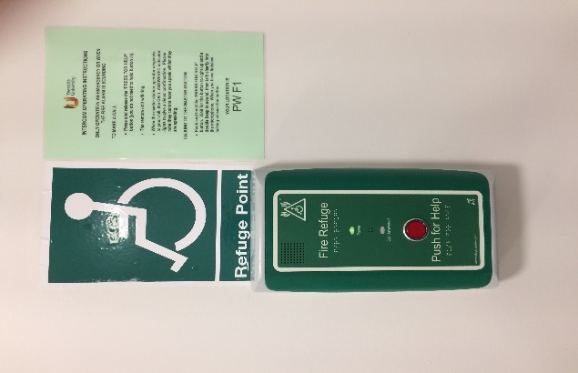 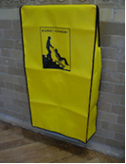 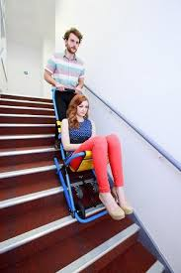

**Visual Impairment:** Most staircases have colour-contrasted markings on the steps. If you require assistance descending stairs, one possibility might be a “buddy system” whereby designated people nearby will assist you; another option might be to use a disabled refuge as described above.

**Hearing Impairment:** Some locations have flashing beacons in addition to fire alarm sirens or bells. Vibrating pagers or pillows, which respond to a fire alarm activation, can be issued. “Buddy systems” as described above might also be suitable.

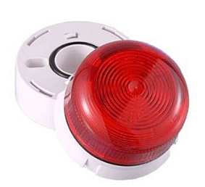 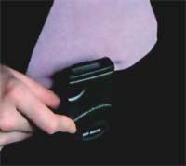 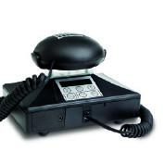

**Student Residences on Campus:** Campus Services (Accommodation) are aware of all rooms allocated to persons with disabilities. In the event of a fire or other incident, Students with PEEPS are a top priority (as for disabled refuges – see above). You can be assured that if you are in any danger, a member of staff will arrive to assist you. If there is no danger to you (e.g. false alarms) they will visit or contact you whenever possible for reassurance – but please note that so long as you are safe, they may have other immediate priorities.

**Temporary PEEPS as a result of medical conditions, injury, pregnancy etc:** Pregnant women, persons with sports injuries, for example broken limbs, persons recuperating from operations/treatment or those with other medical conditions might also need assistance (and therefore a PEEP) in order to evacuate safely.

**Fire Marshals & Security Staff as additional reassurance:** Please note that many University buildings have appointed Fire Marshals. In an evacuation, they will “sweep” designated areas of a building to ensure that no persons remain. They may be able to offer you assistance; at the very least, they will inform Security or Health and Safety staff who will then assist you.

Security Officers proceed immediately to investigate the location of a fire alarm activation identifying where the potential danger is. Having found the cause, they will then investigate the immediate area. Therefore, if you are having difficulty evacuating or have not found your way to a refuge, and if you are in immediate danger from a fire, you will rapidly be found and assisted. However, a properly planned PEEP will greatly reduce the risk to you and those assisting you still further.

**Typical Standard Emergency Evacuation Plans**

**for persons with Medical Conditions**

The following list gives an indication of types of escape arrangements/methods our PEEPS consider, and the possible assistance typically available. These can vary in different circumstances. In most cases the options set out below will form the basis of individual Personal Emergency Evacuation Plans (PEEPS), according to each person’s needs and, where possible, preferences. In some cases a combination of several of these options will apply.

The use of mobile phones should not be discounted but emergency evacuation provisions must not rely on them.

|  |  |  |
| --- | --- | --- |
| **Option** | **Description** | **Comments** |
| 1 | Buddy system | Companion, carer or assistant allocated to assist. This is a voluntary provision and may not always be feasible |
| 2 | Meet assistant at refuge |  |
| 3 | Meet assistant at Workstation | Only practicable with a ‘buddy system’ |
| 4 | Make own way down stairs after main flow dissipates | Appropriate for those that can evacuate themselves slowly |
| 5 | Use of Evac-Chair | Training on the use of Evac-Chair can be provided to those assisting with evacuations |
| 6 | Individual cannot transfer readily to Evac-Chair | Assistance may need to be provided by more than one member of staff |
| 7 | Individual needs assistance to walk down stairs, 1 or 2 people | Only practicable with a ‘buddy system’ |
| 8 | Needs colour contrast on staircases | Most University Buildings have this provided; check whether contrast meets persons individual needs |
| 9 | Person needs showing escape routes | School / Department to arrange |
| 10 | Assistance required for person and guide dog | Utilise ‘buddy system’ |
| 11 | Person needs doors opening | Utilise ‘buddy system’ or investigate providing additional push pads |
| 12 | Person needs large print information or alternative format | Can be provided on request |
| 13 | Identification of escape route | Assess/predetermine most suitable escape route(s) from intended location. Health and Safety can advise on means of escape routes when required |
| 14 | Provision of flashing beacons | Some buildings/locations are provided with these. Additional coverage will be considered where required |
| 15 | Provision of vibrating pager, pillow or alternative alarm | Can be provided when necessary |
| 16 | Horizontal evacuation | Will be implemented wherever possible. For example evacuating to another disabled refuge in the same building away from the incident. |